**IDS 410 – Business Database Technology**

**Fall 2022**

**AWS Lab 2**

**Submitted by:**

**Shubham Dwivedi** [**|sdwive4@uic.edu**](mailto:|sdwive4@uic.edu) **| 660328503**

**Choose Athena from the Services Menu in AWS console.**

**In S3, choose the bucket created and copy the bucket ARN.**

**Setup a Query Result Location in S3**

**Create a new Database in Athena**

**Create a new table from the S3 bucket data inside the Athena console.**

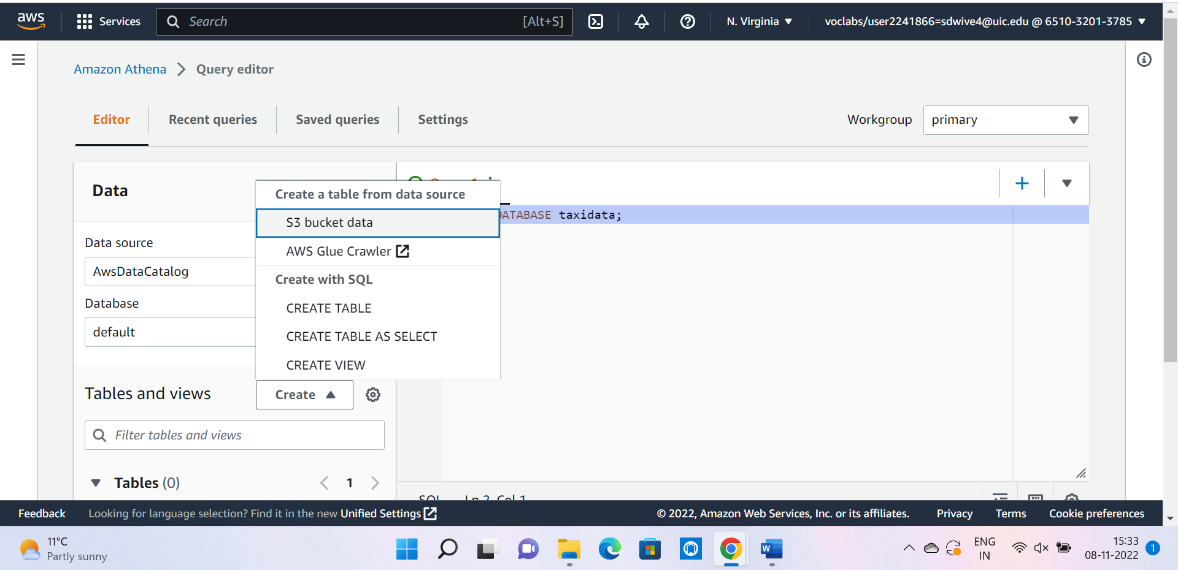

**Location of Input Dataset**

**Bulk add columns in the table.**

**Preview and Create table**

**Preview of the newly created yellow table.**

**Create a new table to store the January 2017 data.**

**Table preview**

**A query by using the data that was not divided into monthly buckets.**

**Results of the Query**

**Stats of the Query**

**A query using the data that is divided into buckets for each month**

**Query Results**

**Query** Stats

**Note: If you are interested in a column with low cardinality, you would partition the data instead of using distinct buckets.**

**Create a partition for paytype = 1**

**Query run in non-partitioned yellow table**

**Query result for non-partitioned table**

**Query run in partitioned yellow table**

**Query result for non-partitioned table**

**create views for the total fares paid for with credit cards and with cash by entering the following two queries:**

**Views created in the Athena dashboard.**

**the query for the calculation for credit cards.**

**the result for the calculation for credit cards.**

**the query for the calculation for credit cards.**

**the result for the calculation for credit cards.**

**The following query will join the data from two views.**

**Preview Comparepay view.**

**Challenge Question 1:**

Select max(pulocid) as “Pickup_Location” from jab where pickup between Timestamp ‘2017-01-01 00:00:00:000’ and Timestamp '2017-01-31 23:59:00:000’;

**2nd Challenge Question**

**SELECT AVG(CASE WHEN paytype = '2' THEN distance END) AS avg_distance_credit_card, AVG(CASE WHEN paytype = '1' THEN distance END) AS avg_distance_cash FROM jan WHERE pickup BETWEEN TIMESTAMP '2017-01-01 00:00:00.000' and TIMESTAMP '2017-01-31 23:59:00.000';**

